**Jessy’s Story**

Jessy is proud to be Head Girl at a secondary school in Kasungu, Malawi. Her parents are farmers and are seeing the effects of climate change now. Jessy helps them on the farm. They grow maize, ground nuts and soya beans.

“My parents depend on farming,” says Jessy.

The weather has changed on the farm since Jessy was little. “It has mostly changed in terms of rain patterns and in terms of seasons. Last time we expected rains at the end of December but nowadays we expect rains in January… This has affected the production of crops. My parents produce very low crops compared to the rest of the years.”

Jessy’s family rely on the farm for their own food. Jessy’s favourite is rice with chicken, nsima and chips. Nsima (pronounced ‘seema’) is a sort of stiff porridge made from maize. Jessy wants to be a nurse or a doctor.

“In Malawi… some people go to hospital but don’t get treatment just because of lack of doctors. So, I decided I wanted to be a doctor so that maybe I can reduce that problem.” (taken from Oxfam ‘Stories of Climate Change)

**Earth’s Climate Story**

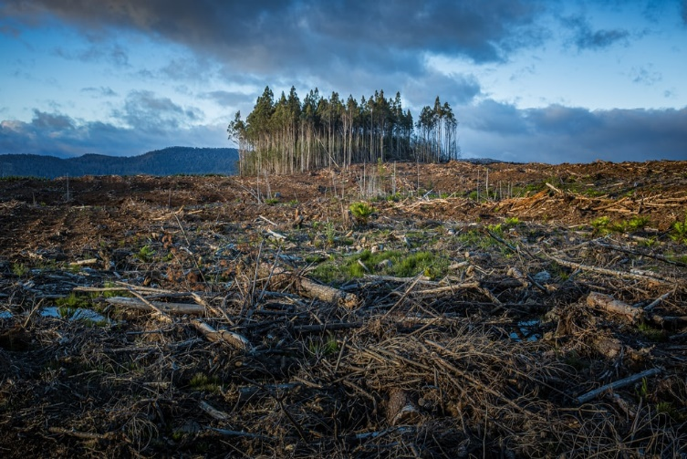

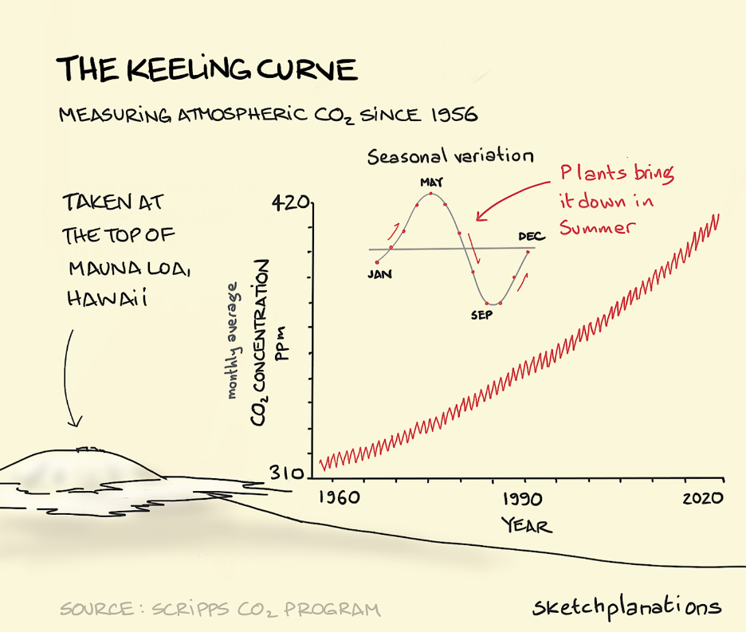

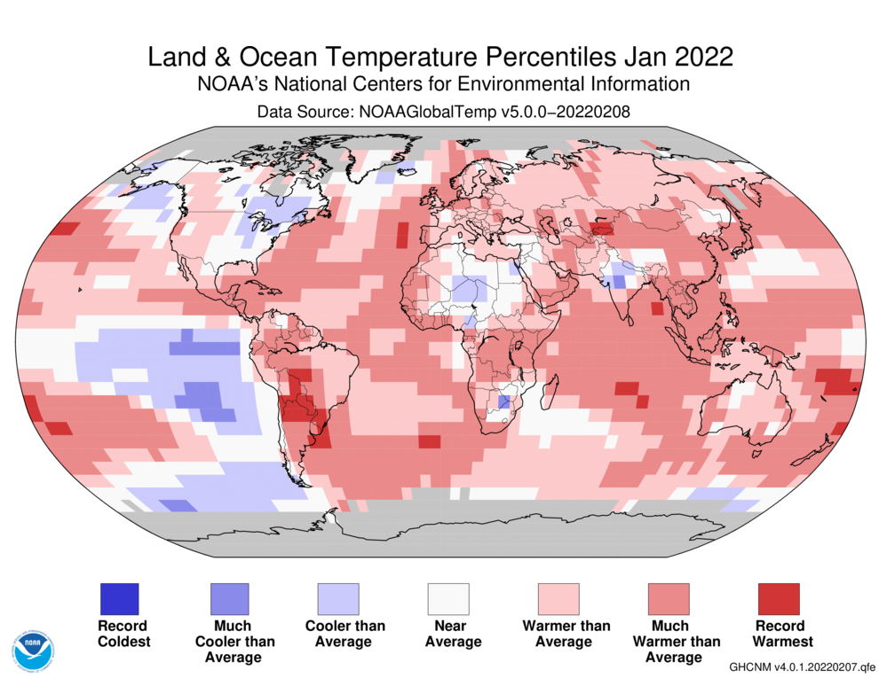

**Earth’s Climate Story**

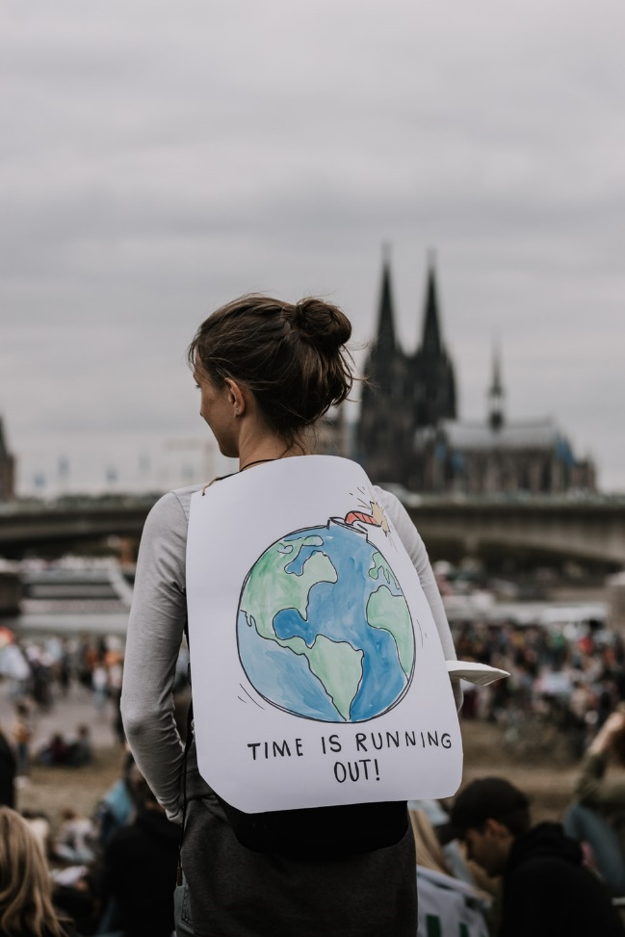

**Vanessa’s Story**

Cyclone Idai made landfall on the night of 14-15 March 2019 - this weather system caused extensive damage in Mozambique, Malawi and Zimbabwe. Strong winds, a storm surge, heavy rains and widespread flooding have had devastating impacts on the lives of millions of people. Homes, roads, bridges, schools and health facilities were destroyed, with agricultural land completely wiped out in some areas.

Vanessa works for Oxfam in Malawi. Following this storm she worked to help people in the Bangula camp in the south of the country where flooding forced many people to leave their homes.

It is not possible to say that any one storm is caused by climate change. However, the best available climate science indicates that climate change is increasing the intensity and frequency of weather-related disasters such as typhoons and droughts.

(taken from Oxfam ‘Stories of Climate Change)

**Earth’s Climate Story**

**Lazaro’s Story**

Lazaro and his family are among the millions of people in Malawi, Mozambique and Zimbabwe whose lives were devastated by Cyclone Idai in March 2019. Strong winds, a storm surge, heavy rains and widespread flooding have had devastating impacts on the lives of millions of people. Homes, roads, bridges, schools and health facilities were destroyed, with agricultural land completely wiped out in some areas.

Lazaro had to build a temporary shelter following the floods which destroyed his house. His family's goats and food were washed away. Lazaro says "These were a source of livelihood and prestige for me. All the food we had was destroyed by the water that came from the river. All we are left with are those poles and tattered plastic."

It is not possible to say that any one storm is caused by climate change. However, the best available climate science indicates that climate change is increasing the intensity and frequency of weather-related disasters such as typhoons and droughts.

(taken from Oxfam ‘Stories of Climate Change)



